[STAT 4400] Exam-1

Michael Ghattas

2/22/2022

# Part 1:

### (1)

True

### (2)

False

### (3)

True

### (4)

True

### (5)

False

### (6)

True

### (7)

True

### (8)

True

### (9)

True

### (10)

False

### (11)

True

### (12)

False

### (13)

False

### (14)

True

### (15)

False

### (16)

True

### (17)

True (IF by reflects we mean cause! As discussed with Bhawneet.)

### (18)

True

### (19)

False

### (20)

False (Correlated Explanatory Variables: If there are very many variables, it is likely that they will be highly correlated, meaning that some variables or sets of variables are measuring similar things. As discussed with Bhawneet.)

# Part 2:

### Problem - 1

library(ggplot2)  
head(msleep)

## # A tibble: 6 × 11  
## name genus vore order conservation sleep_total sleep_rem sleep_cycle awake  
## <chr> <chr> <chr> <chr> <chr> <dbl> <dbl> <dbl> <dbl>  
## 1 Cheetah Acin… carni Carn… lc 12.1 NA NA 11.9  
## 2 Owl mo… Aotus omni Prim… <NA> 17 1.8 NA 7   
## 3 Mounta… Aplo… herbi Rode… nt 14.4 2.4 NA 9.6  
## 4 Greate… Blar… omni Sori… lc 14.9 2.3 0.133 9.1  
## 5 Cow Bos herbi Arti… domesticated 4 0.7 0.667 20   
## 6 Three-… Brad… herbi Pilo… <NA> 14.4 2.2 0.767 9.6  
## # … with 2 more variables: brainwt <dbl>, bodywt <dbl>

##### (1)

df <- na.omit(msleep)  
lmod = lm(sleep_total ~ brainwt, data = df)  
  
ggplot(df, aes(brainwt, sleep_total, color = name)) +  
 geom_point() +   
 geom_smooth(method = lm, color = "red") +  
 theme_bw() + xlab("Average Brain Weight in KG") + ylab("Total Amount of Sleep in Hrs") +   
 ggtitle("Sleep Times vs. Average Brain Weights")

## `geom_smooth()` using formula 'y ~ x'

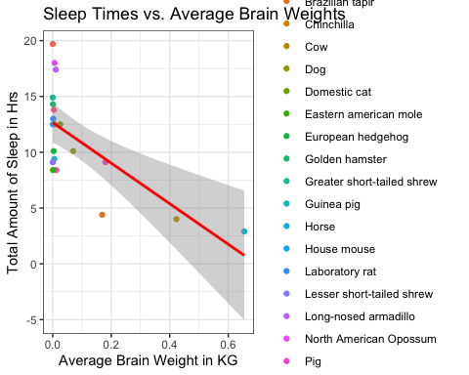 ##### (2)

lmod = lm(sleep_total ~ awake + + bodywt + awake:bodywt + sleep_cycle, data = df)  
summary(lmod)

## Warning in summary.lm(lmod): essentially perfect fit: summary may be unreliable

##   
## Call:  
## lm(formula = sleep_total ~ awake + +bodywt + awake:bodywt + sleep_cycle,   
## data = df)  
##   
## Residuals:  
## Min 1Q Median 3Q Max   
## -2.356e-15 -4.496e-16 1.575e-16 5.642e-16 1.660e-15   
##   
## Coefficients:  
## Estimate Std. Error t value Pr(>|t|)   
## (Intercept) 2.400e+01 8.801e-16 2.727e+16 < 2e-16 ***  
## awake -1.000e+00 7.642e-17 -1.309e+16 < 2e-16 ***  
## bodywt -1.090e-16 3.313e-17 -3.289e+00 0.00497 **   
## sleep_cycle 5.005e-15 1.652e-15 3.029e+00 0.00846 **   
## awake:bodywt 4.777e-18 1.608e-18 2.970e+00 0.00953 **   
## ---  
## Signif. codes: 0 '***' 0.001 '**' 0.01 '*' 0.05 '.' 0.1 ' ' 1  
##   
## Residual standard error: 1.046e-15 on 15 degrees of freedom  
## Multiple R-squared: 1, Adjusted R-squared: 1   
## F-statistic: 8.968e+31 on 4 and 15 DF, p-value: < 2.2e-16

plot(lmod)

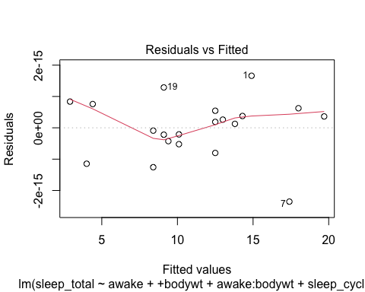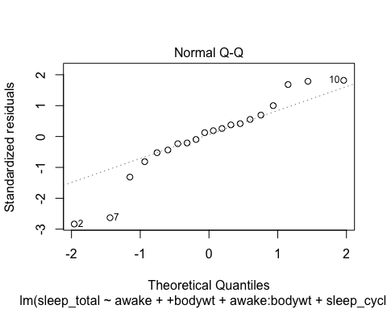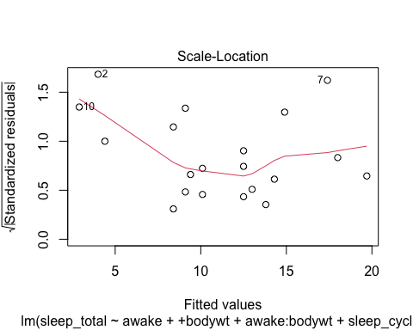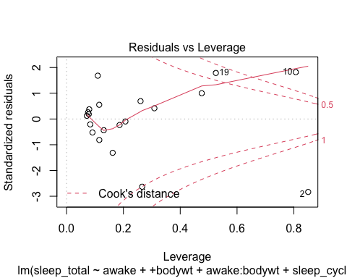

##### (3)

df$sleep_ratio <- (df$sleep_total / 24)  
lmod = lm(sleep_total ~ sleep_ratio, data = df)  
coef(lmod)

## (Intercept) sleep_ratio   
## -7.944109e-15 2.400000e+01

logitSR = (1 / (1 + exp(-1 * (-7.944109e-15 + (2.400e+01 * df$sleep_ratio))))); logitSR

## [1] 0.9999997 0.9820138 0.9999589 0.9999173 0.9999963 0.9998883 1.0000000  
## [8] 1.0000000 1.0000000 0.9478464 0.9999589 0.9999963 0.9999994 0.9999963  
## [15] 0.9997752 0.9999977 0.9997752 0.9999990 0.9998883 0.9878716

lmod = lm(logitSR ~ log(brainwt), data = df)  
summary(lmod)

##   
## Call:  
## lm(formula = logitSR ~ log(brainwt), data = df)  
##   
## Residuals:  
## Min 1Q Median 3Q Max   
## -0.034601 -0.002356 0.001764 0.004298 0.013635   
##   
## Coefficients:  
## Estimate Std. Error t value Pr(>|t|)   
## (Intercept) 0.9812003 0.0051040 192.243 < 2e-16 ***  
## log(brainwt) -0.0029465 0.0009222 -3.195 0.00502 **   
## ---  
## Signif. codes: 0 '***' 0.001 '**' 0.01 '*' 0.05 '.' 0.1 ' ' 1  
##   
## Residual standard error: 0.01004 on 18 degrees of freedom  
## Multiple R-squared: 0.3619, Adjusted R-squared: 0.3264   
## F-statistic: 10.21 on 1 and 18 DF, p-value: 0.005018

Interpreting the results of our coefficients, we can see a negative correlation between the brain weight of the animal and the amount of sleep. For every additional KG of weight, there is a decrease of approximately 0.3% of sleep time needed per 24 hours.

df$sleep_ratio <- (df$sleep_ratio * 24)  
lmod = lm(sleep_total ~ sleep_ratio, data = df)  
coef(lmod)

## (Intercept) sleep_ratio   
## 3.177644e-15 1.000000e+00

logitSR = (1 / (1 + exp(-1 * (3.177644e-15 + (1.000000e+00 * df$sleep_ratio))))); logitSR

## [1] 0.9999997 0.9820138 0.9999589 0.9999173 0.9999963 0.9998883 1.0000000  
## [8] 1.0000000 1.0000000 0.9478464 0.9999589 0.9999963 0.9999994 0.9999963  
## [15] 0.9997752 0.9999977 0.9997752 0.9999990 0.9998883 0.9878716

lmod = lm(logitSR ~ log(brainwt), data = df)  
summary(lmod)

##   
## Call:  
## lm(formula = logitSR ~ log(brainwt), data = df)  
##   
## Residuals:  
## Min 1Q Median 3Q Max   
## -0.034601 -0.002356 0.001764 0.004298 0.013635   
##   
## Coefficients:  
## Estimate Std. Error t value Pr(>|t|)   
## (Intercept) 0.9812003 0.0051040 192.243 < 2e-16 ***  
## log(brainwt) -0.0029465 0.0009222 -3.195 0.00502 **   
## ---  
## Signif. codes: 0 '***' 0.001 '**' 0.01 '*' 0.05 '.' 0.1 ' ' 1  
##   
## Residual standard error: 0.01004 on 18 degrees of freedom  
## Multiple R-squared: 0.3619, Adjusted R-squared: 0.3264   
## F-statistic: 10.21 on 1 and 18 DF, p-value: 0.005018

We can see that returning from 24 hors to hours do not change our results and mantain the sleep time between 0 and 24, though never reaching 0 or 24.

##### (4)

ggplot(df, aes(log(df$brainwt), df$sleep_ratio)) +  
 geom_point() +   
 geom_smooth(method = lm, color = "red") +  
 theme_bw() + xlab("Brain Weight in e^(KG)") + ylab("Total Sleep in Hrs") +   
 ggtitle("Sleep Time per Day vs. Log(Brain Weight)")

## Warning: Use of `df$brainwt` is discouraged. Use `brainwt` instead.

## Warning: Use of `df$sleep_ratio` is discouraged. Use `sleep_ratio` instead.

## Warning: Use of `df$brainwt` is discouraged. Use `brainwt` instead.

## Warning: Use of `df$sleep_ratio` is discouraged. Use `sleep_ratio` instead.

## `geom_smooth()` using formula 'y ~ x'

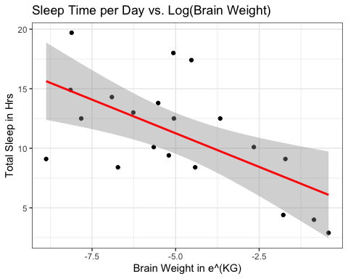

### Problem - 2

homeheat = read.csv('/Users/Home/Documents/Michael_Ghattas/School/CU_Boulder/2022/Spring 2022/STAT - 4400/Data/homeheat.csv')  
head(homeheat)

## idcase depvar ic.gc ic.gr ic.ec ic.er ic.hp oc.gc oc.gr oc.ec oc.er  
## 1 1 gc 866.00 962.64 859.90 995.76 1135.50 199.69 151.72 553.34 505.60  
## 2 2 gc 727.93 758.89 796.82 894.69 968.90 168.66 168.66 520.24 486.49  
## 3 3 gc 599.48 783.05 719.86 900.11 1048.30 165.58 137.80 439.06 404.74  
## 4 4 er 835.17 793.06 761.25 831.04 1048.70 180.88 147.14 483.00 425.22  
## 5 5 er 755.59 846.29 858.86 985.64 883.05 174.91 138.90 404.41 389.52  
## 6 6 gc 666.11 841.71 693.74 862.56 859.18 135.67 140.97 398.22 371.04  
## oc.hp income agehed rooms region  
## 1 237.88 7 25 6 ncostl  
## 2 199.19 5 60 5 scostl  
## 3 171.47 4 65 2 ncostl  
## 4 222.95 2 50 4 scostl  
## 5 178.49 2 25 6 valley  
## 6 209.27 6 65 7 scostl

##### (1)

library("mlogit")

## Loading required package: dfidx

##   
## Attaching package: 'dfidx'

## The following object is masked from 'package:stats':  
##   
## filter

H <- dfidx(homeheat, choice = "depvar", varying = c(3:12))  
m <- mlogit(depvar ~ ic + oc | 0, H)  
summary(m)

##   
## Call:  
## mlogit(formula = depvar ~ ic + oc | 0, data = H, method = "nr")  
##   
## Frequencies of alternatives:choice  
## ec er gc gr hp   
## 0.071111 0.093333 0.636667 0.143333 0.055556   
##   
## nr method  
## 4 iterations, 0h:0m:0s   
## g'(-H)^-1g = 1.56E-07   
## gradient close to zero   
##   
## Coefficients :  
## Estimate Std. Error z-value Pr(>|z|)   
## ic -0.00623187 0.00035277 -17.665 < 2.2e-16 ***  
## oc -0.00458008 0.00032216 -14.217 < 2.2e-16 ***  
## ---  
## Signif. codes: 0 '***' 0.001 '**' 0.01 '*' 0.05 '.' 0.1 ' ' 1  
##   
## Log-Likelihood: -1095.2

Yes, the t-statistics are greater than 1.96, which is the critical level for 95% confidence level.

##### (2)

coef(m)["oc"]/coef(m)["ic"]

## oc   
## 0.7349453

The model implies that the decision-maker is willing to pay 73 cents in higher installation cost in order to reduce annual operating costs by $1.

##### (3)

mc <- mlogit(depvar ~ ic + oc, H, reflevel = 'hp')  
summary(mc)

##   
## Call:  
## mlogit(formula = depvar ~ ic + oc, data = H, reflevel = "hp",   
## method = "nr")  
##   
## Frequencies of alternatives:choice  
## hp ec er gc gr   
## 0.055556 0.071111 0.093333 0.636667 0.143333   
##   
## nr method  
## 6 iterations, 0h:0m:0s   
## g'(-H)^-1g = 9.58E-06   
## successive function values within tolerance limits   
##   
## Coefficients :  
## Estimate Std. Error z-value Pr(>|z|)   
## (Intercept):ec 1.65884594 0.44841936 3.6993 0.0002162 ***  
## (Intercept):er 1.85343697 0.36195509 5.1206 3.045e-07 ***  
## (Intercept):gc 1.71097930 0.22674214 7.5459 4.485e-14 ***  
## (Intercept):gr 0.30826328 0.20659222 1.4921 0.1356640   
## ic -0.00153315 0.00062086 -2.4694 0.0135333 *   
## oc -0.00699637 0.00155408 -4.5019 6.734e-06 ***  
## ---  
## Signif. codes: 0 '***' 0.001 '**' 0.01 '*' 0.05 '.' 0.1 ' ' 1  
##   
## Log-Likelihood: -1008.2  
## McFadden R^2: 0.013691   
## Likelihood ratio test : chisq = 27.99 (p.value = 8.3572e-07)

apply(fitted(mc, outcome = FALSE), 2, mean)

## hp ec er gc gr   
## 0.05555556 0.07111111 0.09333333 0.63666667 0.14333333

Exact match: alternative-specific constants in a logit model insure that the average probabilities equal the observed shares.

##### (4)

wtp <- coef(mc)["oc"] / coef(mc)["ic"]  
wtp

## oc   
## 4.563385

r <- 1 / wtp  
r

## oc   
## 0.2191356

The willingness to pay is USD(4.56) for a $1 year stream of savings. The decision-maker applies a 22% discount rate, thus the results are certainly more reasonable than in the previous model.

##### (5)

Hn <- H  
Hn[idx(Hn, 2) == "hp", "ic"] <- 0.88 * Hn[idx(Hn, 2) == "hp", "ic"]  
apply(predict(mc, newdata = Hn), 2, mean)

## hp ec er gc gr   
## 0.06640050 0.07031239 0.09228286 0.62933328 0.14167096

The share is predicted to rise to about 6.64% when rebates are given.

##### (6)

plot1 = ggplot(homeheat, aes(ic.gc + ic.gr + ic.ec + ic.er + ic.hp, oc.gc + oc.gr + oc.ec + oc.er + oc.hp, color = idcase)) +  
 geom_point() +   
 geom_smooth(method = lm, color = "red") +  
 theme_bw() + xlab("Installation Cost") + ylab("Annual Operating Cost") +   
 ggtitle("Installation vs. Operational Cost")  
  
plot2 = ggplot(homeheat, aes(agehed, income)) +  
 geom_point(shape = 21, color = "darkgoldenrod4", fill = "darkgoldenrod3", size = 5) +   
 theme_light() + xlab("Age") + ylab("Income Class") +   
 ggtitle("House-Head Age vs. Income Class")  
  
library(gridExtra)  
grid.arrange(plot1, plot2, ncol = 2)

## `geom_smooth()` using formula 'y ~ x'

